DESIGN AND ANALYSIS OF DUAL BAND MICROSTRIP PATCH ANTENNA FOR WIRELESS APPLICATIONS
A Design and Simulation of Antennas report submitted in partial fulfillment of the requirements for the award of

BACHELOR OF TECHNOLOGY
in

ELECTRONICS & COMMUNICATION ENGINEERING

by

CHILUKURI MALLIKHARJUN REDDY (20761A0476)



DEPARTMENT OF ELECTRONICS & COMMUNICATION ENGINEERING
LAKIREDDY BALI REDDY COLLEGE OF ENGINEERING
(AUTONOMOUS)
L.B.Reddy Nagar, Mylavaram – 521 230.
Affiliated to JNTUK, Kakinada & Approved by AICTE, New Delhi Accredited by NBA and NAAC
Certified by ISO 9001-2015 December- 2022

LAKIREDDY BALI REDDY COLLEGE OF ENGINEERING (AUTONOMOUS)
L.B.Reddy Nagar, Mylavaram – 521 230.
Affiliated to JNTUK, Kakinada & Approved by AICTE, New Delhi Accredited by NBA and NAAC, Certified by ISO 9001-2015

DEPARTMENT OF ELECTRONICS & COMMUNICATION ENGINEERING



CERTIFICATE

This is to certify that Design and Simulation of Antennas report entitled “DESIGN AND ANALYSIS OF DUAL BAND MICROSTRIP PATCH ANTENNA
FOR WIRELESS APPLICATIONS” is duly presented and submitted by CHILUKURI MALLIKHARJUN REDDY(20761A0476) in partial fulfillment of requirement for the award of Bachelor of Technology in Electronics and Communication Engineering in Lakireddy Bali Reddy College of Engineering (A), Mylavaram, during the academic year 2022-2023.

Internal Examiner External Examiner

ACKNOWLEDGEMENT

The Satisfaction that accompanies the successful completion of any task would be incomplete without the mention of people whose ceaseless co-operation made it possible, whose constant guidance and encouragement crown all efforts with success.

I humbly express my thanks to our Principal Dr. K. Appa Rao for extending his support and for providing us with an environment to complete our project successfully.

I would also like to thank our Vice Principal, Dr. K. Harinadha Reddy for encouraging us which certainly helped to complete the project in time.

I deeply indebted to our Head of Department Dr. Y. Amar Babu, who modeled us both technically and morally for achieving greater success in life.

I extremely thankful to my guides Dr. P. Raesh kumar, Dr. V. Ravi Sekhara Reddy, Dr. Y.V.N.R. Swamy and Smt. M.V.L. Bhavani, Department of Electronics and Communication Engineering, for their excellence guidance, timely and valuable suggestions and encouragement that enabled the success of the project.

I would like to thanks Advanced Communication lab technician Mr M. Anji Reddy, Department of Electronics and Communication for his support throughout the period of our project work for making it a successful one.
I would like to express my heart full thanks to our parents for their unflinching support and constant encouragement throughout the period of our project work for making it a successful one.
I would like to thank all the teaching and non-teaching staff members of Electronics and Communication Engineering who have extended their full co-operation during the course of our project.
I thank all my friends who helped us sharing knowledge and by providing material to complete the project in time.

CHILUKURI MALLIKHARJUN REDDY (20761A0476)

CONTENTS
Page No

List of Figures i

List of Tables iii
iv

Abstract v

CHAPTER 1 INTRODUCTION 1
  - INTODUCTION TO ANTENNAS 1
  - MICROSTRIP ANTENNAS 1
  - SUBSTRATES 2
  - FEEDING TECHNIQUES 3
    - Microstrip line 4
    - Co-axial feed 4
    - Aperture coupling 4
    - Proximity coupling 4
  - RADIATION MECHANISM 5
  - SIMULATION TOOL USED 8
    - Applications to HFSS 9
    - System requirements to run HFSS 9
  - FABRICATION METHODS 10
    - Photolithography process 10
    - PCB prototype modelling 11
  - AMENITIES FOR ANTENNA MEASUREMENT 11
    - Anechoic chamber 11
    - Vector Network Analyzer 12

1.9 | RESEARCH MOTIVATION | 13
1.10 | OBJECTIVE OF THE RESEARCH | 13
1.11 | ORGANIZATION OF THESIS | 14
CHAPTER | 2 LITERATURE SURVEY | 15
2.1 | MICROSTRIP PATCH ANTENNAS | 15
2.2 | MULTIBAND MICROSTRIP PATCH
 | ANTENNAS | 16
2.3 | WIDEBAND MICROSTRIP ANTENNAS | 16
2.4 | WIDE BAND MICRO STRIP PATCH | 17

ANTENNA USING DEFECTED GROUND STRUCTURE

2.5 DUAL BAND PATCH ANTENNA 18
CHAPTER 3 THEORITICAL ANALYSIS 20
  - PROPOSED DESIGN 20
  - DESIGN SPECIFICATIONS 22
    - Frequency of operation 22
    - Dielectric constant of the substrate 22
    - Height of Substrate 22
CHAPTER 4 DESIGN OF MICRO STRIP PATCH USING HFSS 26
  - OUTLINE OF A PATCH ANTENNA 26
  - DRAWING A SUBSTRATE 27
  - PATCH 29
  - GROUND PLANE 30
  - MICROSTRIP FEED LINE 32
  - ASSIGN EXCITATION 32
  - ANALYSIS SETUP 33
  - SOLUTION SETUP 33
  - ADD FREQUENCY SWEEP 33
  - MODEL VALIDATION 33
  - ANALYZE 34
  - CONCLUSION 34
CHAPTER 5 EXPERIMENTAL RESULTS 35
  - ANTENNA DESIGN 35
    - Antenna design with square patch 36
    - Antenna design with modified patch 36
    - Antenna design with modified patch 38
    - Antenna design When substrate is 39
modified
  - VSWR 42
  - CONCLUSION 42
CHAPTER 6 CONCLUSION AND FUTURE SCOPE43
  - CONCLUSION 43
  - FUTURE SCOPE 43
REFERENCES 44

 | List of Figures
Fig No | Figure Name | Page No
1.1 | Structure of Microstrip antenna | 02
1.2 | Different feeding techniques | 03
1.3 | Radiation mechanism | 05
1.4 | Curved wire | 06
1.5 | Bent wire | 06
1.6 | Discontinuous wire | 07
1.7 | Terminated wire | 07
1.8 | Two-wire Transmission line | 07
1.9 | Photolithography Process | 10
1.10 | PCB Prototype machine | 11
1.11 | Anechoic chamber | 12
1.12 | Vector Network Analyzer | 12
3.1 | Design of circular patch antenna | 20
3.2 | Design flow of Proposed antenna | 24
4.1 | Original design of antenna | 26
4.2 | Solution type Selections | 26
4.3 | Choose of default value | 27
4.4 | (a) Drawing of substrate | 28
 | (b) Dimensions of substrate | 28
 | (C) substrate | 28

  - Patch modelling 29
  - Patch dimensions modelling 29
    - Patch 29
  - Strip 30
  - Ground formation 30
    - Ground formation with dimensions 31
      - Ground 31
  - Feed formation 32
  - Feed dimensions 32
  - Validations checked 34
  - Iteration-1 35
  - Return loss for Iteration-1 35
    - VSWR for Iteration-1 36
  - Iteration-2 36
  - Return loss for Iteration-2 37
    - VSWR for Iteration-2 37
  - Iteration-3 38
  - Return loss for Iteration-3 38

  - VSWR for Iteration-3 39
  - Itration 4 39
  - Return loss for itration 4 40
  - VSWR for itration 4 40
  - Schematic configuration of Iterations-1,2,3,4 41
  - Simulated return loss for different iterations (1,2,3,4) 41

List of Tables

Table No Table Name Page No
  - Various substrates used for design of

Patch antenna 02

  - Comparison of various feeding techniques 05

3.1 Dimensions of the proposed antenna 21

5.1 Parametric performance analysis of various Parameters variation 42

ABSTRACT

Microstrip antenna is the main key building for wireless communication and global positioning system, to support the high mobility necessity for a wireless communication, low volume and light weight antenna is preferred. The espousal of microstrip patch antenna is applicable for different areas specifically military, telecommunication satellites and surgical applications many more, but microstrip antennas have some disadvantages such as low gain and narrow bandwidth.
In this project, a “dual band patch antenna is proposed and explored for wireless applications”. The proposed antenna having dimensions of 30 X 35 X
1.6 mm3 using a FR-4 epoxy substrate having relative permittivity of εr =4.4. The microstrip patch antenna at frequency range 8.2GHz and 9.5GHz. circular patch is modified by introducing circular slots at each corner, the functionality of the proposed antenna is analyzed with parameters like VSWR, return loss. The proposed antenna suitable for wireless applications such as X- band (8-12GHz). The simulated and measured results are in good agreement.

v

CHAPTER 1
INTRODUCTION

INTRODUCTION TO ANTENNAS

An antenna is typically a metallic device that emits or receives radio waves (such as a rod or wire). In other terms, an antenna is a structure that sits in between free space and a directing tool and is used to transmit electromagnetic energy from a transmitting source to the antenna as well as receive electromagnetic energy from a receiver to the antenna. Antennas can be divided into two groups. Both directional and omnidirectional antennas are used here. While directional antennas emit more energy in one direction than the others, omnidirectional antennas radiate energy roughly equally in all directions. Radiation optics research was pioneered by Sir Jagadeesh Chandra Bose. The waves in his groundbreaking microwave study were shrunk to a millimeter’s level, with a wavelength of roughly 5 millimeters. He was also the first to use a semiconductor junction to detect radio waves.
When choosing or designing an antenna for a certain application, a user will be concerned with several performance criteria that define antennas. Gain, beamwidth, radiation pattern, impedance, and polarization are some of an antenna's properties.

MICROSTRIP ANTENNAS

In telecommunication, a microstrip antenna means an antenna fabricated using microstrip techniques on a printed circuit board and are mostly used at microwave frequencies. Microstrip antenna consists of a patch of various shapes on the surface of a PCB with a ground plane onthe other side of the PCB [4]. The RF current is given between the antenna and ground plane. In recent years, these antennas have their importance due to their thin planar structure used in various products, aircraft and missiles, their ease of fabrication using different techniques etc[8]. A patch antenna is a narrow- band, large beam antenna fabricated by removing the antenna element pattern in metal trace bonded to an insulating dielectric substrate, such as a printed
LAKIREDDY BALI REDDY COLLEGE OF ENGG DEPARTMENT OF ECE
1

circuit board, with ametal layer attached to the opposite site of the substrate which creates a ground plane.
Microstrip patch antenna is made of three materials as shown in figure.1.1. They are 1) ground 2) patch 3) substrate.
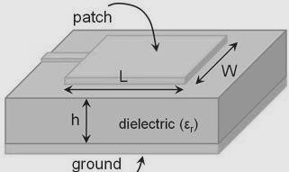

Figure.1.1 Structure of Microstrip antenna
Microstrip antennas can be of different like square, rectangular, circular, elliptical, and any continuous possible shape.

SUBSTRATES
The usage of substrate is principally needed in microstrip antennas for the mechanical support of the antenna. To support stability substrate should consist of a dielectric material which effects the electrical performance of the antenna and transmission line.
Table.1.1 Various substrates used for design of patch antenna

Name of the substrate | Relative permittivity
Diamond | 1
Teflon | 2.1
Taconic RF-35 | 3.5
Rogers RT/duroid 5880 | 2.2
Rogers RO4350 | 3.66
Epoxy Glass | 3.4
FR4 Epoxy | 4.4

LAKIREDDY BALI REDDY COLLEGE OF ENGG DEPARTMENT OF ECE
2

Dielectric Substrate: FR-4 (high loss, low gain antenna, cheap, easy availability); low loss and low permittivity (RT Duroid 6002, PTFE, high gain antennas); portable n mobile (RO4730, high performance, low weight, low permittivity, low loss, low distortion); ceramic (Rogers RO 3200, low cost, GPS patch antenna) etc. Dielectrics are used for improved mechanical and electrical stability. They are utilized to decreasethe size of the antenna (higher permittivity, lower size) and can assist with creating displacement current which produces time changing Magnetic Field (by Ampere's Law). This can thus deliver time differing Electric Field (by Faraday's law) and a propagating EM field is created. Thus, a substrate can improve antenna's radiation capacity.

FEEDING TECHNIQUES

Microstrip antenna can feed by variety of methods. Those methods are of two categories-contacting and non-contacting schemes. The foremost popular feeding techniques are microstrip line, co-axial, proximity coupling and aperture coupling .

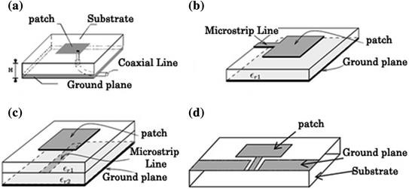

Figure.1.2 Different feeding techniques

    - Microstrip Line

In this feeding technique, a conducting strip is directly connected to the edge of the patch as shown in figure.1.2. This type of feed also called Offset Microstrip line feed (contacting scheme). The advantage is that the feed can be etched on the same substrate to provide a planar structure. It provides ease of fabrication, impedance matching [5].

Co-axial feed

the most common feeding technique used for microstrip antennas is Co- axial feed (or probe feed). An inner conductor of co-axial connector extends through the dielectric substrate and is soldered or attached to the radiating patch and the outer conductor is connected to the ground plane as shown in Figure.1.2(b). The advantage of probe feed is that the feed can be placed at any desired position to provide impedance matching.

Aperture coupling

Aperture coupled feed is an indirect method of feeding the patch (non- contacting scheme) shown in figure.1.2(c). It couples the patch antenna with microstrip line through an aperture and creates an electric filed in the aperture which induces surface currents on the patch. The disadvantage of this technique is that difficult to fabricate because ofhaving multiple layers, also increases the thickness of the antenna.

Proximity coupling

This feeding technique also called as electro-magnetic coupling scheme. In this feeding, two substrate materials are used so that the feed line is given in between those two substrates and the patch is on top of the upper substrate material shown in figure.1.2(d). Here, also the thicknessof antenna increases.

Table 1.2 Comparison of various feeding techniques

Characteristics | Co-axial feed | Aperture coupled feed | Proximity coupled feed | Microstrip line feed
Spurious feed  radiation | More | Less | Minimum | More
Bandwidth | 2-5 % | 21% approx. | 13% approx. | 2-5 %
Ease of  fabrication | Drilling & Soldering  needed | Alignment is required | Alignment is required | Easy
Reliability | Poor dueto soldering | Good | Good | Better
Impedance  matching | Easy | Easy | Easy | Easy

  - RADIATION MECHANISM

The main purpose of an antenna is power radiation or reception. The Antenna can be attached to the circuitry at the station through a transmission line. The performance of an antenna depends upon the radiation mechanism of a transmission line.
The radiation from an antenna occurs when the Electromagnetic field is generated by a source is transferred to an antenna equipment through the Transmission line and separated from the Antenna into free space.
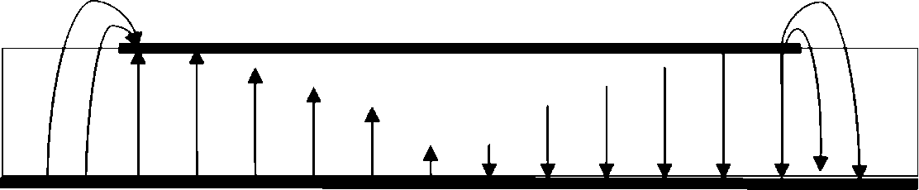

Figure.1.3 Radiation mechanism

Radiating mechanism is of two types 1. single wire 2.two wire
- Single-wire: radiation in an antenna occurs if the wire is curved, discontinuous, bent and terminated and when the charge is oscillating in time-domain, it radiates even the wire is straight .
Different wire configurations for single wired antenna radiation are

  - Curved wire: helical antenna and loop antennas comes under this category these type of antennas are used for high frequency portable transceivers which are used in ultra-wide band communications.
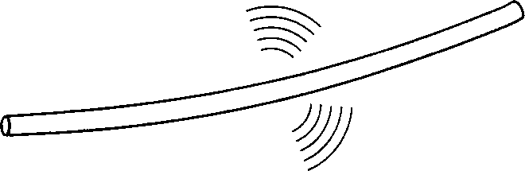

Figure.1.4 Curved wire

  - Bent wire: the radiation takes place more efficiently when the wire is bent, either it may be single end or at both the ends of the wire because the flow of transmitted energy tries to escape from the transmission line
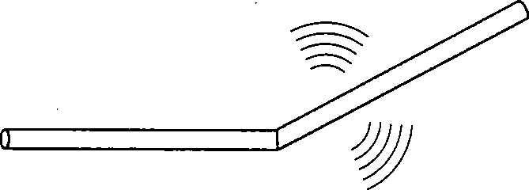

Figure.1.5 Bent wire

  - Discontinuous wire:

The flow of transmission of energy is very high when the wave is transmitting from one boundary to another, this discontinuity in the medium is called as discontinuous wire

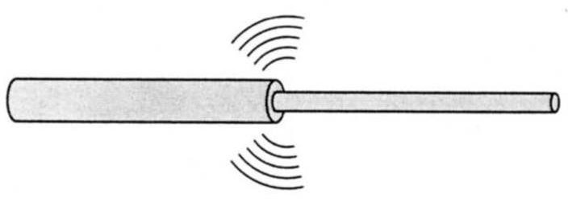

Figure.1.6 Discontinuous wire

  - Terminated wire: the perfect termination in an antenna occurswhen the wire is properly terminated, this type of wired antennas can work even in noisy environment without any tuners
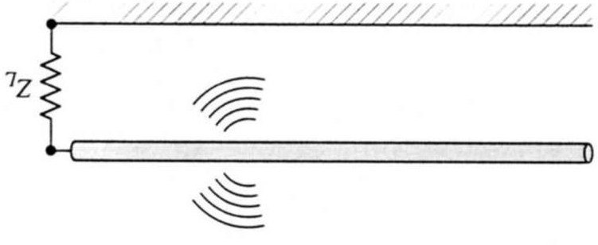

Figure.1.7 Terminated wire

- Two-wire:

Let us assume that a voltage source is connected to a two-conductor transmission line which is connected to an antenna. By introducing the voltage across the two-conductor line transmission produces a strong electric filed between the conductors. Both linear and half dipole comes under this two-wire radiation mechanism.
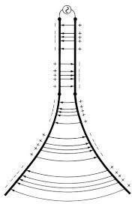

Figure 1.8 Two-wire Transmission line

  - SIMULATION TOOL USED

HFSS is a predominant full wave electromagnetic (EM) field test system for subjective three-dimensional volumetric detached gadget demonstrating that exploits the common place Microsoft Windows graphical UI. It coordinates reproduction, portrayal, strong displaying, and mechanisation in an easy to learn condition where answers for your 3D EM issues are quickly and precise gotten. Ansoft HFSS uses the Limited Component Technique (FEM), versatile cross section, and magnificent illustrations to give you unmatched execution and knowledge to the majority of your 3D EM issues. Ansoft HFSS can be used to determine parameters, for example, S-Parameters, Resounding Recurrence, and Fields.
Typical uses include:

- Package Displaying – Flip-Chip, QFP, BGA

- PCB Load up Displaying – Power or Ground planes, Work Network Grounds, Back planes.
Silicon/GaAs-Winding Inductors, Transformers.

- Connectors – Cajole, XFP/SFP, Back plane, Advances.

- Waveguide – Channels, Resonators, Changes, Couplers.

- Filters – Pit Channels, Miniaturized scale strip, Dielectric.

- HFSS is an intelligent reproduction framework whose essential work component is a tetrahedron. This enables you to unravel any subjective 3D geometry, particularly those with complex bends and shapes, in a small amount of the time it would take utilizing different methods.
- The name HFSS represents High Recurrence Structure Test system. Ansys spearheaded the utilization of the Limited Component Strategy (FEM) for EM recreation by creating/executing advances, for example, digressive vector limited components, versatile cross section, and Versatile Lancozos - pade Breadth (ALPS). Today, HFSS keeps on coming out on top with advancements, for example, Modes to Hubs and Full-wave Zest.

- Ansys HFSS has advanced over a time of years with contribution from numerous clients and businesses. In industry, Ansys HFSS is the apparatus of decision for High profitability research, advancement, and virtual prototyping.

APPLICATIONS OF HFSS

HFSS is utilized in different field to mimic and get required examples. Some of them are
      - Antennas

      - Microwave advances

      - Waveguide segments

      - RF channels

      - Three-dimensional discontinuities

      - Passive circuit components

SYSTEM REQUIREMENTS TO RUN HFSS

ANSYS, CFX, Familiar, AUTODYN, HFSS, and MAXWELL are

altogether bolstered on Windows 7 64-bit. This stage gives the investigation network incredible figuring limit while conveyed at item estimating. A multicore 64-bit processor framework can address a lot of Smash and permit huge document sizes. A recommended examination framework might be something like:
- Double Six Center or Eight Center Processors

- Windows 7 64bit

- 1 GB (or higher) illustrations card (DRD has had great involvement
with NVIDIA cards).

- 12-48 GB of Smash

- DVD R/W Drive

FABRICATION METHODS

Antennas can be fabricated using two methods. They are (1) Photolithography process (2) PCB prototype machine.

PHOTOLITHOGRAPHY PROCESS
The format is made utilizing CAD devices and print out of the negative veil of the plan is made on a straightforward or a semi- transparent sheet. To expel impurities from the metallization of the substrate, it is cleaned with acetone. A blend of photoresist and slenderer in the proportion 1:1 is made and covered over the substrate. In the wake of drying, the veil is put over the substrate and is presented tothe UV light. The uncovered substrate is then plunged in the developer solution for solidifying the photoresist in the uncovered part. The covered segment must be expelled. The substrate is plunged in the dye to show signs of improvement perceivability of the uncovered photoresist and washed utilizing water. The undesirable copper portions are evacuated utilizing the etching procedure utilizing Ferric chloride. FeCl3 disintegrates the unexposed copper covering. Photolithography process is shown in figure.1.9.
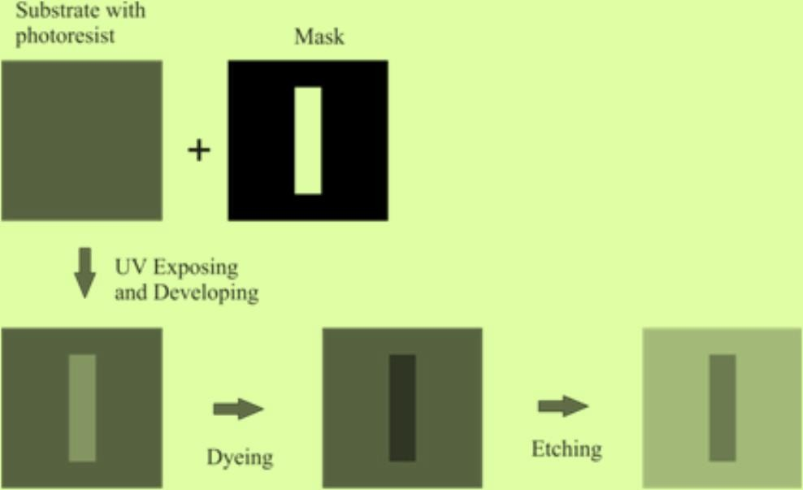

Figure.1.9 Photolithography process

    - PCB Prototype Modelling
Hardware implementation of designed antenna is done using PCB Prototype machine which is the process of removing the areas of copperfrom a sheet of substrate material i.e., printed circuit board to recreate the structures according to the designed antenna from HFSS simulation software. PCB milling is a non- chemical process and it can be done in alab environment without exposure to hazardous chemicals.
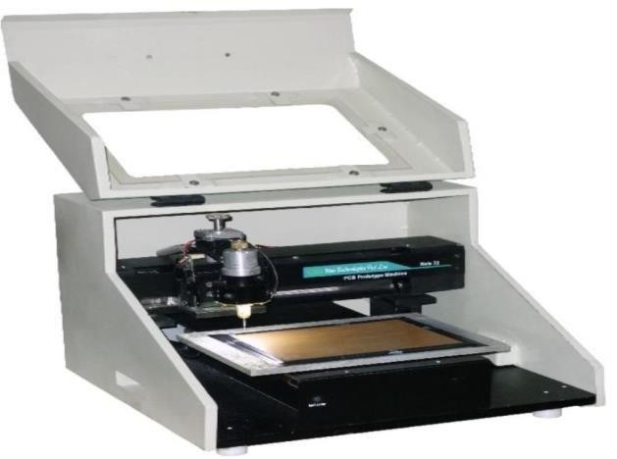

Figure.1.10 PCB Prototype machine

  - AMENITIES FOR ANTENNA MEASUREMENT

Testing of real antennas are measured using anechoic chamber and vector network analyzer and the importance of these instruments aredescribed below.

ANECHOIC CHAMBER

An anechoic chamber is a room which absorbs all the reflections of either electromagnetic waves or sound. In-addition they are confined from waves entering from their environment. This means that a human can hear only direct sounds, in effect simulating being inside a large room. For testing antennas, radars RF anechoic chamber is used inwhich interior surfaces are covered with radiation absorbent material instead of acoustically absorbent material shown in figure.1.11. RF anechoic chambers are used for measuring of antenna radiation patterns, electromagnetic interference.

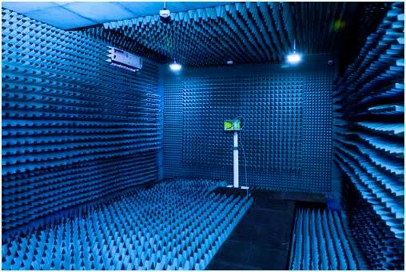

Figure.1.11 Anechoic chamber

    - VECTOR NETWORK ANALYZER

Vector network analyzers are used for testing and verifying component specifications and design simulations respectively for making sure that their elements work properly. A Vector Network Analyzer contains both a source used for generating a stimulus signal and a set of receivers which are used for determining the changes in the stimulus caused by device-under-test or DUT. A VNA is a test system that enables the RF performance of microwave devices and radio frequency microwave devices to be analyzed in terms of network scattering parameter, or S- parameters shown in figure.1.12.
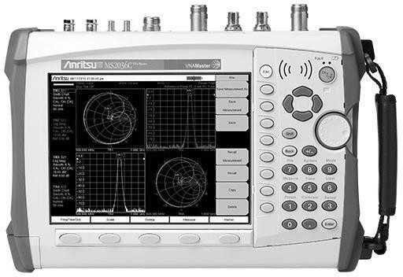

Figure.1.12 Vector Network Analyzer

  - RESEARCH MOTIVATION

The growth of wireless communication and information transfer is in demand for various applications. They created the need for advancements of antenna designs which acts as an important part of any wireless system. There are different types of antennas, one of those antennas that is required for wireless communication is microstrip antennas. These antennas have different configurations and presently used as an active field in the research and development of antennas. Due to advantages of microstrip antennas, there are wide range of applications in wireless communications. Thus, using single antenna we can make use of wideband, dual band or multiband applications.

OBJECTIVE OF THE RESEARCH

The objective of our project is to design and simulate a novel compact dual band patch antenna using for wireless applications. In the design of microstrip patch antenna we can the drawback of narrow bandwidth . Thus, we can obtain higher data rate and greater bandwidth. In our proposed design circular slots are introduced in the patch.

ORGANIZATION OF THE THESIS

The Thesis is organized into 6 chapters

Chapter 1: Discuss about the introduction to microstrip antennas, mainly about feeding techniques, HFSS simulation software and system requirements of it. Motivation towards the present work is also discussed.
Chapter 2: Antennas in literature for different applications are reviewed. Also, antennas with different patches surveyed for dual band frequencies.
Chapter 3: Theoretical analysis of the proposed antenna is discussed and also design specifications are mentioned. The design flow of the proposed antenna is discussed.
Chapter 4: Describes how proposed antenna is designed using HFSS simulation software and shows step by step procedure to design a microstrip patch antenna.
Chapter 5 : Gives a detailed analysis of the proposed antenna performance and results are shown. The characteristics of the proposed antenna are observed and plotted.
Chapter 6: Concludes the highlights of our work in the thesis and future scope of the antenna are discussed.

CHAPTER 2
LITERATURE SURVEY
In this literature survey, how a microstrip antenna is designed is observed through different research papers. The following survey describes the step-by-step analysis of design of a microstrip patch antenna. The limitations of microstrip antenna are less data transmission capacity and low gain. These limitations are improved by using various shapes of patch antennas.

MICROSTRIP PATCH ANTENNAS

Le Chang et al; Triple-Band Microstrip Patch Antenna and Its Four Antenna Module Based on Half-Mode Patch for 5G 4 × 4 MIMO Operation which operates at frequency bands of 2.47–2.75 GHz, 3.39–3.60 GHz[8], and 4.69–5.10 GHz, which makes a nice compromise between antenna volume and impedance bandwidths. 5G has brought several new sub-6 GHz bands (such as N77, N78, and N79) and the new 4 × 4 multiple-input multiple- output (MIMO) specification, which greatly increase the antenna number of a 5G device.
Houda Werfilli et al designed a rectangular microstrip patch antenna whose reflection coefficient is less than -10dB, operates at 3.1-5.1GHz[5], in which they explained about different feeding techniques but works only for few applications.
Gazala Pravin et al proposed a low cost microstrip patch antenna array for wireless communications which is designed for high-speed wireless local area networks[4], in which a good VSWR value was observed but this antenna operates only at 5GHz frequency band.

MULTIBAND MICROSTRIP PATCH ANTENNAS

Abdolmehdi Dadgarpour et al ; Slotted ground plane is used to increase the resonant frequencies[1]. This antenna can support applications like PCS, WLAN, Bluetooth, WiMAX, HIPERLAN. When -6 dB is used as reference this antenna covers DCS band (1.71-1.88 GHz). Radiation efficiency is more than 80% in all surveyed bands.
Vyshnavi Das S K et al designed a Multiband Microstrip Patch Antenna for IOT Applications[18] . In this paper the size of the antenna is 130mm X 90mm. The antenna has the resonant frequencies of 1.54GHz, 2.73GHz, 3.63GHz, 4GHz, 4.61 GHz, 5.32 GHz, and 6.44 GHz.
Radouane KARLI et al designed a multiband microstrip patch antenna for wireless communications[13] . In this paper the size of the antenna is 45mm ×70mm. This antenna supports wireless applications like GSM cellular phone system, Wi-Fi, WLAN, Bluetooth.
Yi Liu, Xi Li, Lin Yang, and Ying Liu designed a Dual-Polarized Dual-Band Antenna With Omni-Directional Radiation Patterns[20]. Which has operating frequency of 1566—1584 MHz and 2440—2472 MHz. The antenna can be a good candidate for both GPS and WLAN applications.

WIDEBAND MICROSTRIP ANTENNAS

S. Taha Imeci et al designed a Wideband Microstrip Patch Antennaat 7 GHz[15]. In this paper an edge-fed microstrip antenna was designed which operates at 7.1Ghz and having a gain of 4.5dB. this antennaoperates only at one frequency and having a return loss of 10%.
Deependra Khandelwal et Al proposed a Multi-Frequency Wideband Microstrip Patch Antenna for Wlan/Hiperlan/ Satellite Applications [3]. In this paper a rectangular microstrip patch antenna which is having a multi frequency bandwidth of 385MHz, 517MHz and 1111MHz was proposed which are applicable only for WLAN, HIPERLAN and satellite communication systems.

Bharatendra singh niboriya et al designed a S-shape Wideband Microstrip patch Antenna with Enhanced gain and Bandwidth forWireless Communications[2]. In this paper the proposed antenna is applicable for S- Band and C-Band but having a very less impedance bandwidth of 67.23%.
Vivek Singh Rathor et al designed a swastika shaped wideband microstrip patch antenna for GSM/WLAN Application[17], which operates at 1.6GHz- 2.5GHz and can be used for GSM and WLAN Applications having a good impedance bandwidth but operates at very low frequencies.
M. Gunavathi et al designed a miniaturized UWB microstrip patch antenna for wireless communication [10]. In this paper, an E-shaped microstrip patch antenna is designed to support UWB frequency ranges and it supports wireless applications like Wi-Fi, WLAN, WiMAX and satellite applications. It operates at six resonant frequencies.
S. Sri Harsha et al designed a microstrip patch antenna using UWB for wireless communication devices[14] . In this paper a monopole antenna which is a having low profile and low volume was constructed and operates at very low frequencies.
Karishma D et al designed a wideband Monopole Square microstrip patch antenna[7] . In this paper the antenna operates from 2.47- 9.28GHz with an impedance bandwidth of 117%. Here, less gain is achieved i.e, gain=2.36dB.
MHD Amen Summakieh et al propose a Single Wideband Microstrip Patch Antenna for 5G Wireless Communication Application[9]. In this paper they discussed about an antenna which operates at 6GHz frequency which is having less size, but bandwidth of 500MHz only.

WIDEBAND MICROSTRIP PATCH ANTENNAS USING DEFECTEDGROUND STRUCTURE
Jing Pei et al; Radiating element consists of circular ring andY-shaped like strip[6]. The width and length of 50ohm microstrip feed is 2.4 mm and 12.06 mm. Cambered ground plane is used at the back side of ground plane. Isosceles

triangle is etched in the ground plane under the microstrip feed for impedance matching. The gap between the circular ring and the arc shaped strip affects the impedance performance and resonant frequencies of the antenna. The defected ground-plane acts as a filter for removing unnecessary frequencies. After adding Y-shaped strip the antenna resonates at dual band such as 2.58 GHz, 3.58 GHz. The radiation pattern in the H-plane is omnidirectional whereas E-plane is monopole.
Wen-Chung Liu et al [19]; Slots are used in the ground plane to excite the resonant modes and improve the impedance matching. The obtained bandwidth covers the WLAN standards (2.4/5.2/5.8 GHz) and WiMAX standard (3.5/5.5 GHz). Without using defected ground plane antenna is not matched. With the use of L-shaped strips improves impedance matching and excite additional resonance. Radiation patternis nearly omnidirectional. With the increase in operating band, efficiency increases but the directivity decreases because current in lower frequency is more in-phase and concentrated in the same direction for high directivity.
Praveen nartam et al designed an ultra-wide band antenna using defected ground structure [12]. In this paper, Ultra-wideband (UWB) antenna with two blend edges at the rear end of the microstrip patch and microstrip feedline at the fore side is presented. The backside has partial ground plane with triangular-shaped slots. It operates at frequencies between 3.58-9.93GHz with a bandwidth of 6.35GHz

Dual-Band MICRO STRIP PATCH ANTENNA

Miaomiao Zuo, Jian Ren, and Ying Zeng Yin designed a Dual-Band Antenna With Large Frequency Ratio Based on Dual-Mode Transmission Line[11]. Which has operating frequencies of 2.49–3.70 GHz, 22.0–40.0 GHz

Yuan-Ming Cai, Ke Li, Ying-Zeng Yin, and Xueshi Ren designed a Dual-Band Circularly Polarized Antenna Combining Slot and Microstrip Modes for GPS With HIS Ground Plane.Which has operating frequencies of 1.210–1.250 GHz and 1.555–1.605 GHz[21]. This antenna can be used for gps applications.

S. H. S. Esfahlani, A. Tavakoli, and P. Dehkhoda designed a A Compact Single- Layer Dual-Band Microstrip Antenna for Satellite Applications[16]. The dual-band behavior is achieved by a shorting pin at 1.7–1.706 and 8.011–8.277 GHz.

CHAPTER 3 THEORETICAL ANALYSIS

PROPOSED DESIGN

A rectangular patch antenna is designed by the arrangement ofpartial slotted ground structure. C i r c u l a r patch is created by inserting a circle having radius 10mm2. The circular patch is modified by introducing circular slot in the patch having radius R1=2mm, R2=mm, R3=2mm, R4=2mm, R5=2mm after that by making a defect at each corner of patch in the shape of circle with radius R2=2. It is fabricated on FR-4 substrate with dielectric constant ℇr =4.4. The dimensions of the antenna are Length=40mm and Width=50mm and Height=1.6mm respectively. The feeding method used to excite the antenna is microstrip feed line.

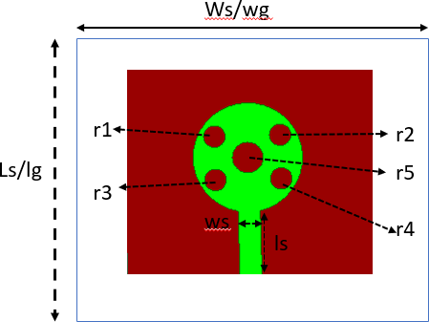

Figure.3.1 Design of circular patch antenna

Parameter |  | Dimension (mm)
Length of the substrate(ls) |  | 40
Width of the substrate(ws) |  | 50
Ground Length(lg) |  | 40
Ground Width(wg) |  | 50
Feed line Length |  | 4
Feed line Width |  | 3.2
Radius of circle  (R) |  | 10
Patch Length |  | 16.5
Patch Width |  | 4
Radius of Circular slots in Patch  (R1, R2, R3,R4,R5) |  | 2
Length of strip(ls) |  | 16.5
Width of strip(ws) |  | 4

Table no 3.1: Dimensions of the proposed antenna

DESIGN SPECIFICATIONS

The three essential parameters for the design of a rectangular Microstrip Patch Antenna is

FREQUENCY OF OPERATION (F)

The resonant frequency of the antenna must be chosen properly. The Personal Communication system (PCS) utilizes the frequency range from 1850-1990 MHz’s. Hence the antenna structured must be able to operate in this frequency range. For our design 10 GHz resonant frequency is selected.

DIELECTRIC CONSTANT OF THE SUBSTRATE (Ε)

For our design FR4 EPOXY dielectric material is selected which is having dielectric constant of 4.4. To reduce the dimensions of the antenna A
substrate with a high dielectric constant is selected. Here, FR indicates Fire Retardant and number 4 indicates glass epoxy resin.

HEIGHT OF DIELECTRIC SUBSTRATE (H)

For the micro strip patch antenna to be used in cellular mobiles, it is important that the antenna should not bulky in size. Hence, the height of the dielectric substrate is selected as 1.6 mm.

Calculation of the width ‘W’

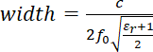

      - Calculation of the Effective Dielectric Constant

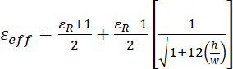

Calculation of Length

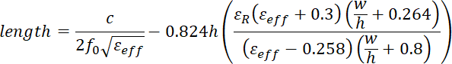

Where fo= Resonant frequncy, h= thickness of substrate, ℇR= Relative permittivity.

Return Loss

Return loss is a figure that means the proportion of radio waves appearing at the input of the antenna that are eliminated as a ratio against those signals that are taken. For example, a reception apparatus. In the system that the power given to the antenna under-test (AUT) is P (in) and the power returned back to the input port is P(ref), the level of difference between the occurrence and returned power in the travelling waves is given by the proportion Pin/Pref. If this level results higher then,the better the impedance matching is obtained.
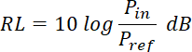
Expressed in dB, return loss is defined

Which is a positive quantity if ref in P < Pi. Also defined in another way, RL is the difference in decibels between the power transferred towards the AUT and the power reflected. It is a positive non-dissipative term representing the decrease in strength of the reflected wave in comparisonwith the incident one. This is the situation for a passive AUT. A negative return loss is possible with

active devices. Expressing the power in terms of voltage (similar to field strength) in a transmission line (assuming a passive AUT), then above equation becomes
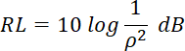

Where ρ is the reflection coefficient at the input of the antenna under test AUT. That is, return loss is the negative of the reflection coefficient expressed in terms of decibels. In terms of the voltage standing wave ratio (VSWR) then

The design flow of proposed antenna is shown in Figure.4.2

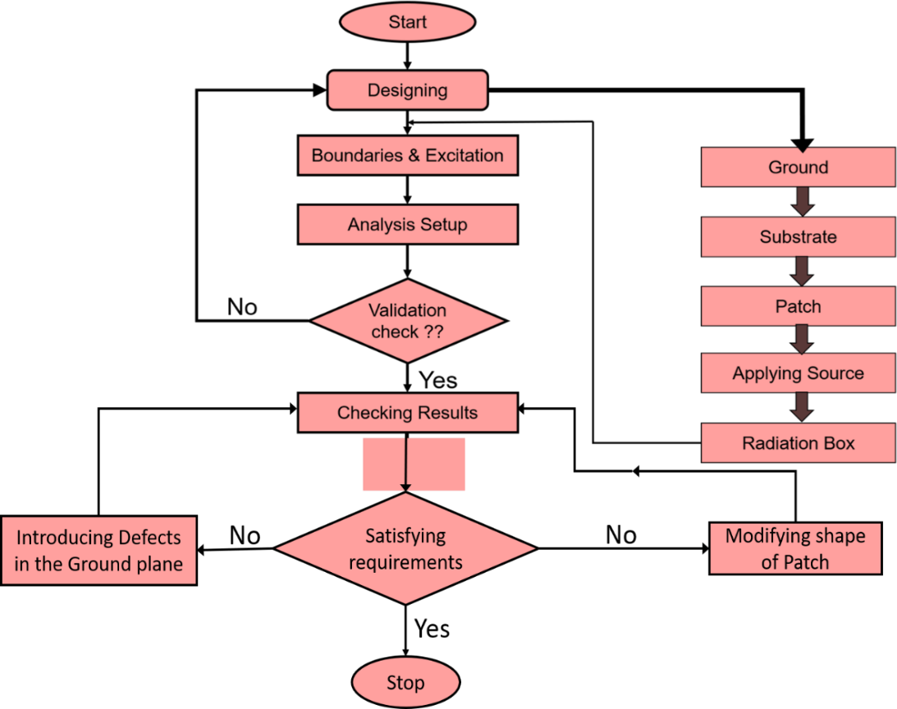

Figure.3.2 Design flow of Proposed antenna

The above figure describes the design flow of the proposed antenna. Initially, HFSS design environment is created. However, we know that microstrip
antenna consists of 3 layers. They are ground, substrate, and patch. First the

ground plane is drawn using rectangle shape tool. The ground and the patch are two dimensional. Substrate layer is created by using box as it is having thickness of 1.6mm. Patch is also drawn using rectangle tool and dimensions are given as per the Table.4.1. Now, the input to the microstrip antenna can be given by using offset feeding technique and it is also drawn using rectangle shape. Since the ground and patch are conducting materials, we assign boundary as Perfect E (copper material) and substrate is taken as FR4 epoxy material. Excitation is given through lumped ports. In this design as we are dealing with radio waves, we need to simulate the results in a closed chamber. Thus, after completion of design of antenna structure we go for validation check and then checking results whether the results obtained are satisfied with our requirements. If not, further we go for either modifying shape of patch or introducing defected ground structure. After getting optimized results we stop the process.

CHAPTER 4

DESIGN OF MICRO STRIP PATCH USING HFSS

OUTLINE OF A PATCH ANTENNA

The objective of this section is to show how to create, simulate and analyze a microstrip patch antenna resonating at frequency of 8.2GHz and 9.5GHz as shown in fig 5

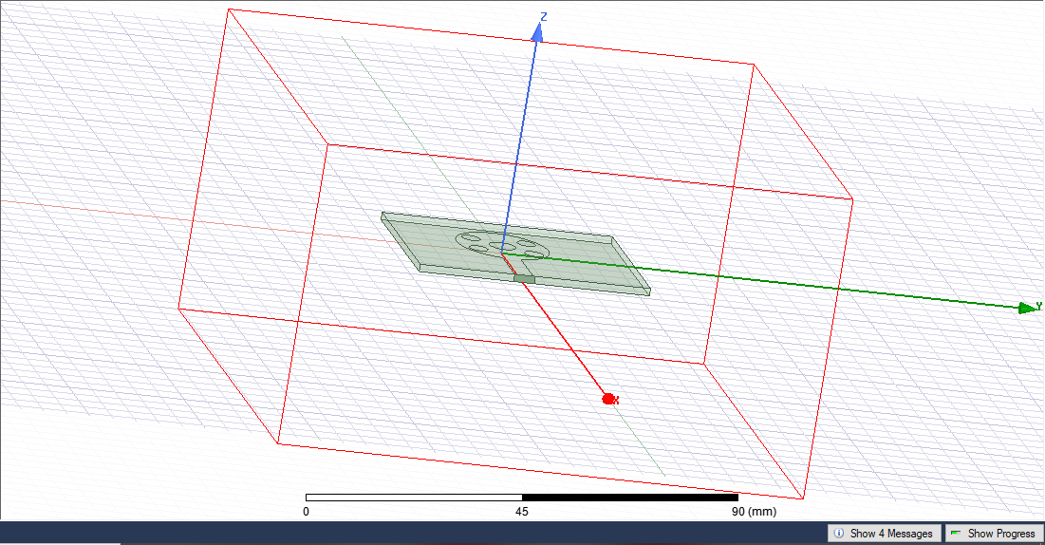

Figure.4.1(a) Original Design of Antenna
To set the solution type:

- Select the menu item HFSS > Solution Type
- Solution Type Window
- Choose Driven Model
- 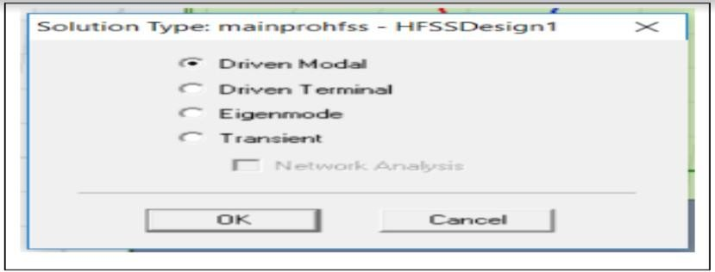Click the OK button

Figure.4.2 Solution Type Selections

Set Model Units

To set the units:
    - Select the menu item 3D Modeler > Units

    - Set Model Units:

    - Select Units: mm

    - Click the OK button To set the default material:
    - Using the 3D Modeler Materials toolbar, choose Select

    - Select Definition Window:

    - Type FR4 epoxy in the Search by Name field; Click the OK button

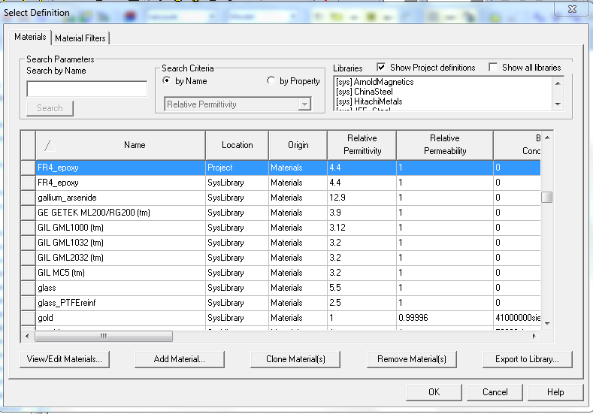

Figure.4.3 Choose of default value 4.2DRAWING A SUBSTRATE

To draw the Substrate, click on the toolbar. Then draw a box by filling the following data as shown below.

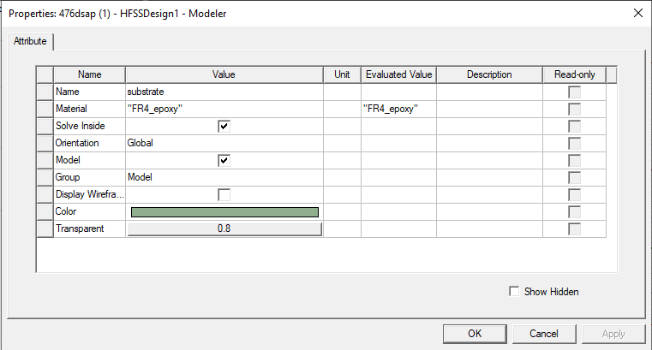

Figure.4.4(a) Drawing Of substrate

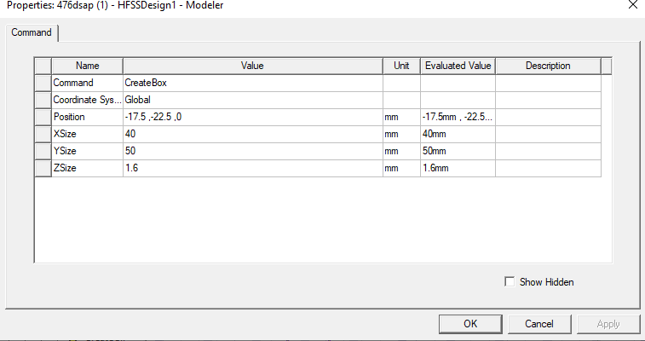

Figure.4.4(b) Dimensions Of substrate
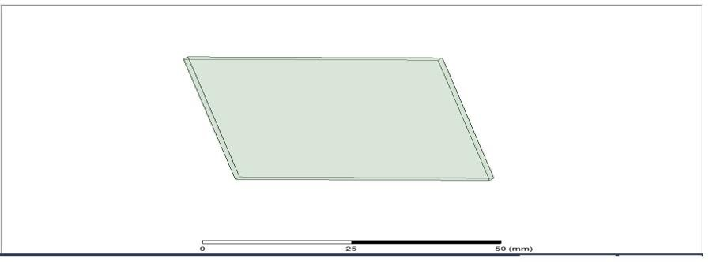
Figure.4.4(c) substrate

PATCH
To draw the rectangular Patch, click on the toolbar. Then draw a box tool by giving the following data as shown below.
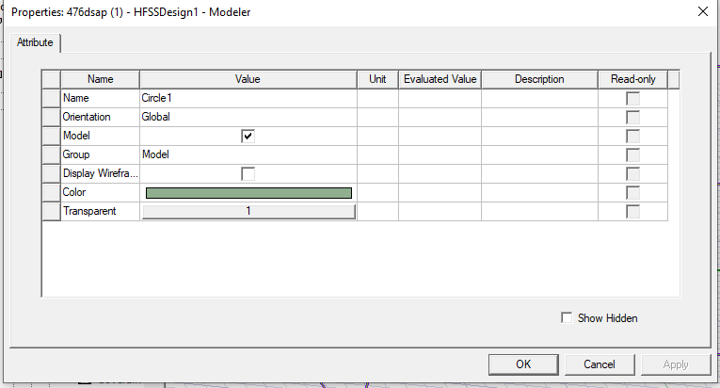

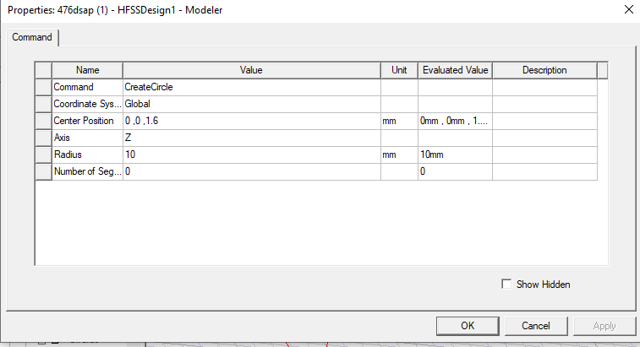
Figure 4.5 Patch modelling
Figure.4.6 Patch dimensions modelling


Figure.4.6(a) Patch

Strip:
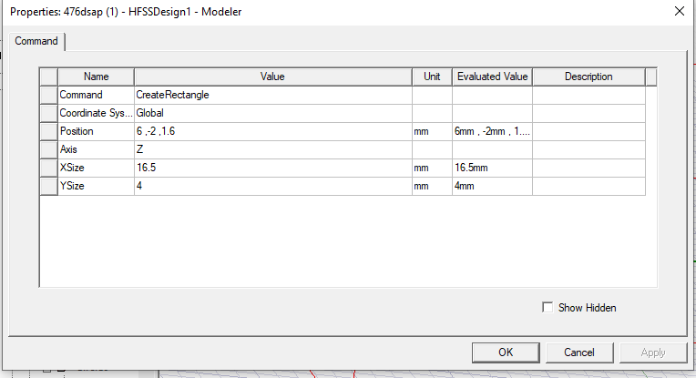

Fig 4.7 STRIP
As we all know that the Patch and strip line are considered to be single object and same material. So, we must unite them. Click on both objects that you need to unite that is Patch and Feedline in the history tree. Click on one and hold the CTRL key and click on the other. Right Click Edit > Boolean > Unite. Thus, these 2 objects are united.

GROUND PLANE
To draw the Ground Plane, click on the toolbar. Then draw a box by giving the following data as shown below.
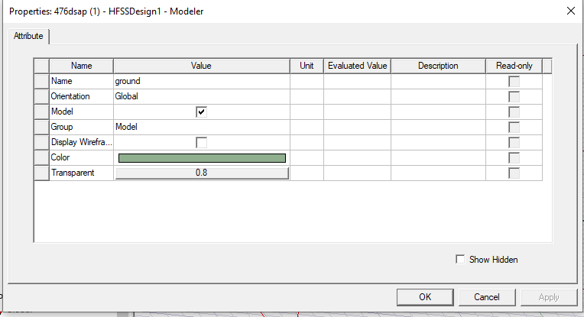

Figure.4.8 Ground formation

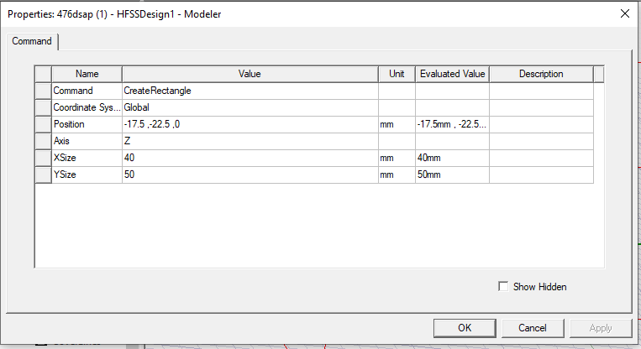

Figure.4.8.1 Ground formation with dimensions
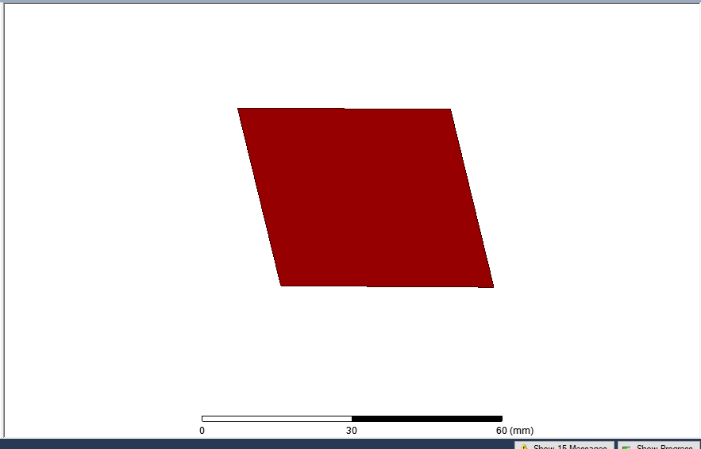

Figure.4.8.1(a) Ground

  - MICROSTRIP FEED
To draw the Microstrip Feed, click on the toolbar. Then draw a planein ZX axis with corresponding dimensions as shown in the following figure.
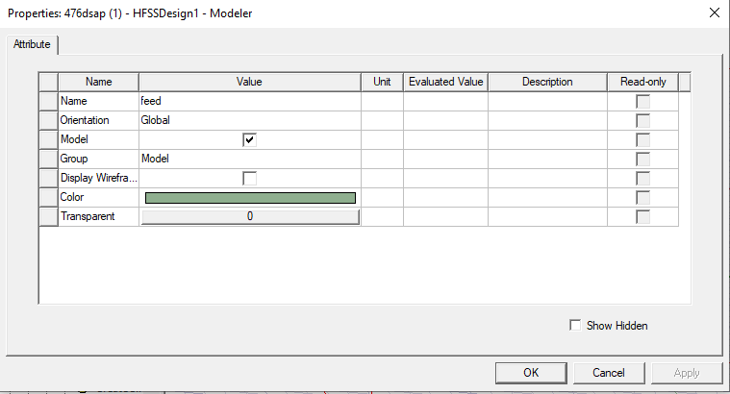

Figure.4.9 Feed formation
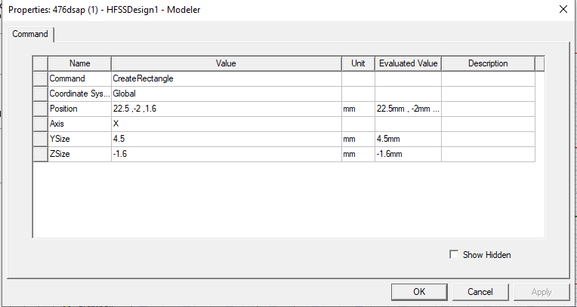

Figure.4.10 Feed dimensions

ASSIGN EXCITATION

In Microstrip feed line the conducting strip is connected to edge of the patch. Antennas are excited through Lumped port in this feeding technique. To draw the input port, click on the toolbar. Then draw aplane as per the dimensions by giving the following data as shown below.

Choose the object Port from history-tree, right-click and assign excitation. In our case, it is lumped port. Click lumped port, name it as your preference.
To assign Lumped-port excitation

Select the menu item HFSS > Excitations > Assign > Lumped port Lumped port: General
Name: p1

Click the Next button

ANALYSIS SETUP

After design is completed, it is ready to run. Now, we have to give analysis setup. To create an analysis setup, select the menu item

HFSS > Analysis-Setup > Add.

SOLUTION SETUP

In the Solution-Setup window, click the general tab, Solution frequency is 5 GHz, Maximum Number of Passes are 20 and loss tangent per Pass is 0.02.

ADD FREQUENCY SWEEP

To add a frequency sweep, select the menu item as

HFSS > Analysis Setup > Add Sweep. Select Solution Setup: Setup-1. Click OK button. Then Edit Sweep Window. Sweep Type: Fast, Frequency Setup Type: Linear Count, start: 1 GHz, Stop: 10 GHz, Count: 1000. Click OK button.

MODEL VALIDATION

To validate the designed model, select the menu HFSS > Validation Check. Click the Close button. If any errors or warnings messages occurred go to the Message Manager.

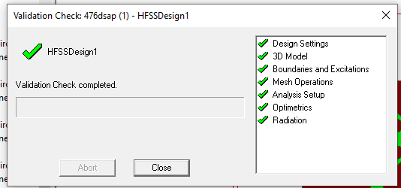

Figure.4.11 Validations checked

ANALYZE

To run the simulation, click the green exclamation point in the toolbar (located next to the green validation check mark). This will run all simulation setups associated with the current design. Alternatively, you may right-click on an individual solution setup (such as in the Project Manager and select 'Analyze').

CONCLUSION

In this chapter the complete design of the microstrip patch antenna using HFSS is discussed and mentioned about analysis setup, solution setup. In next chapter, the parametric analysis is done to analyze the characteristics of proposed antenna and experimental results are observed.

CHAPTER 5 EXPERIMENTAL RESULTS
  - ANTENNA DESIGN

The recursive process of designing the proposed antenna is carried out by changing iteration-1 to iteration-3 to obtain high impedance bandwidth 5.1.1Antenna design with circle patch (Iteration-1)
Initially, a antenna with dimensions of 40 x50 mm2 is designed. This antenna operates at frequency range 7.9 GHz .



Figure 5.1 Iteration-1
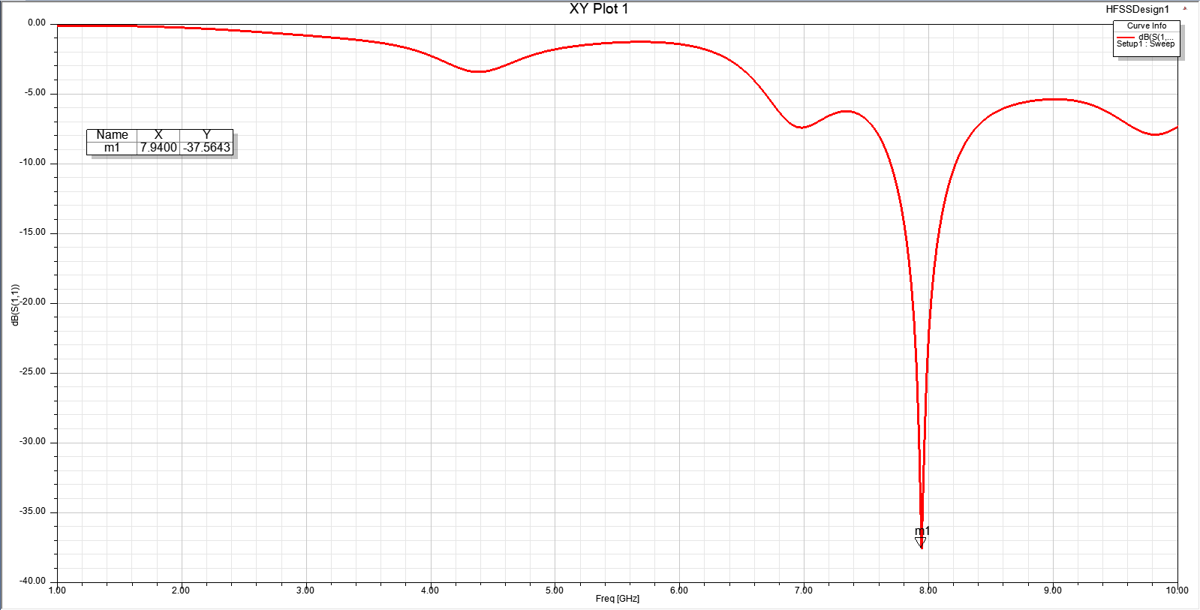

Figure.5.2 Return loss for Iteration-1

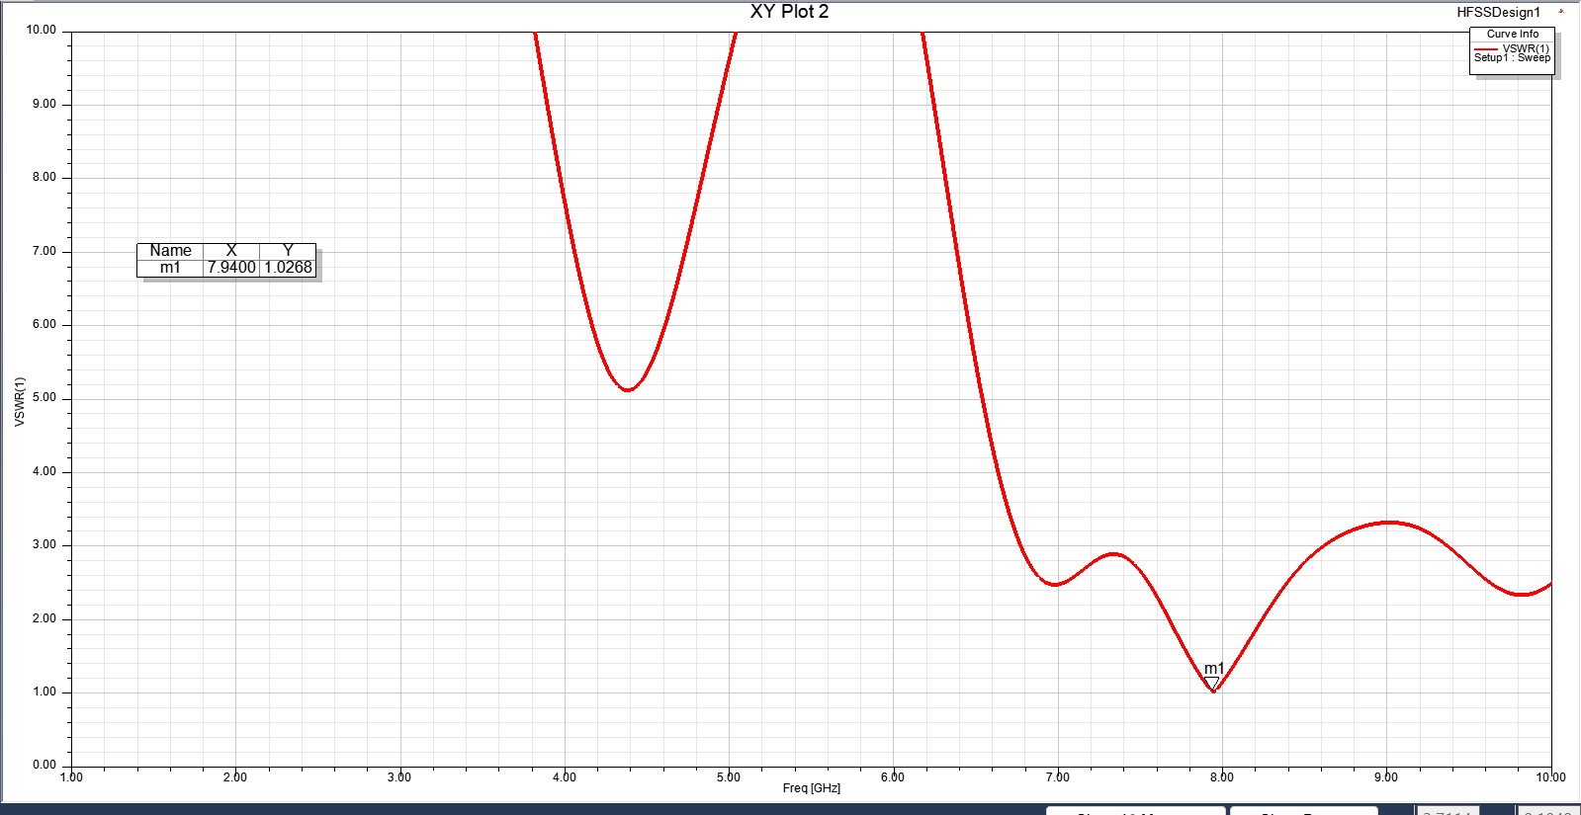

Figure.5.2(a) Vswr for Iteration-1

    - Antenna design with modified patch (Iteration-2)

an antenna with dimensions of 40 x50 mm2 is designed. This antenna operates at frequency range 8.1GHz and 9.7GHz.


Figure.5.3 Iteration-2

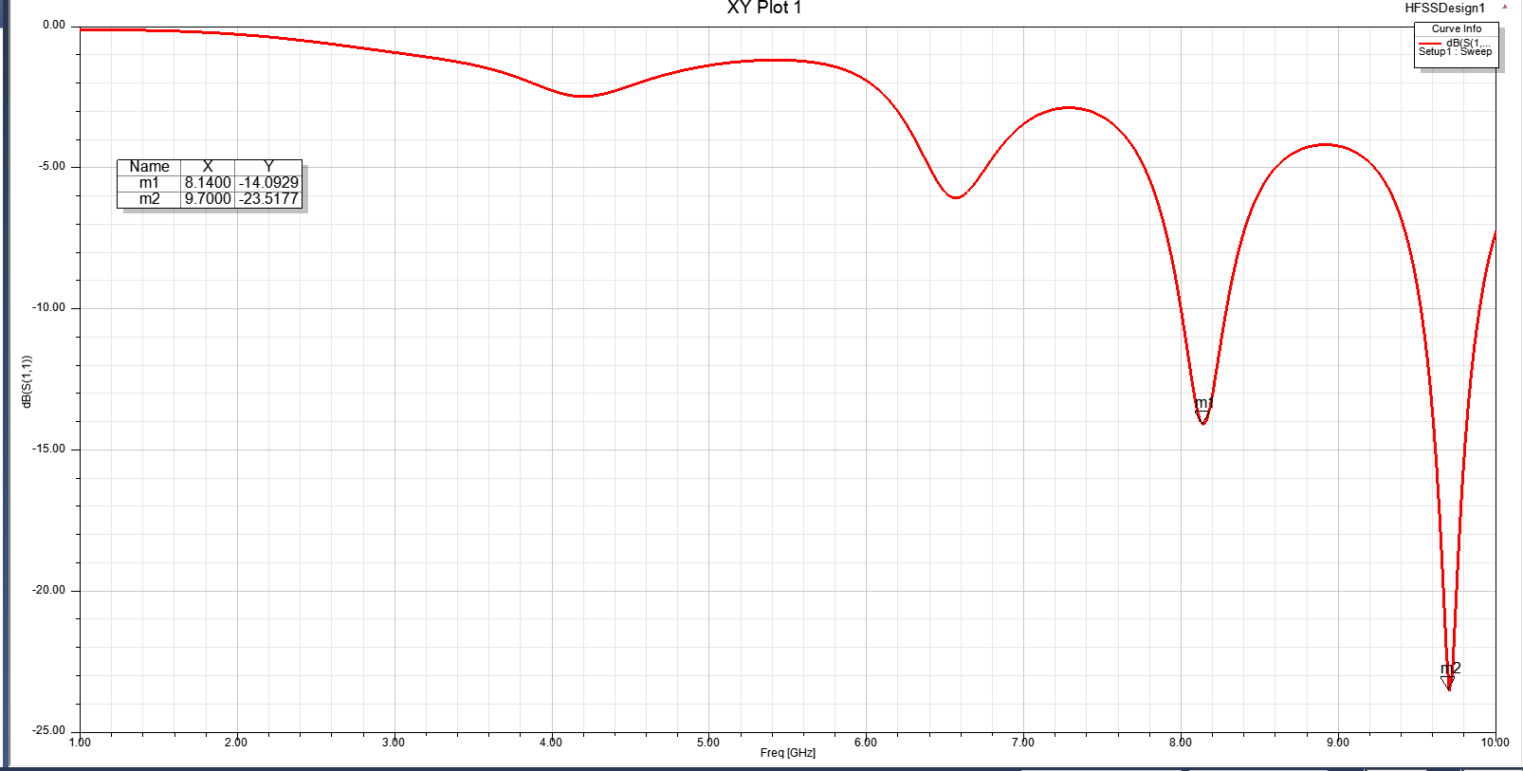

Figure.5.4 Return loss for Iteration-2
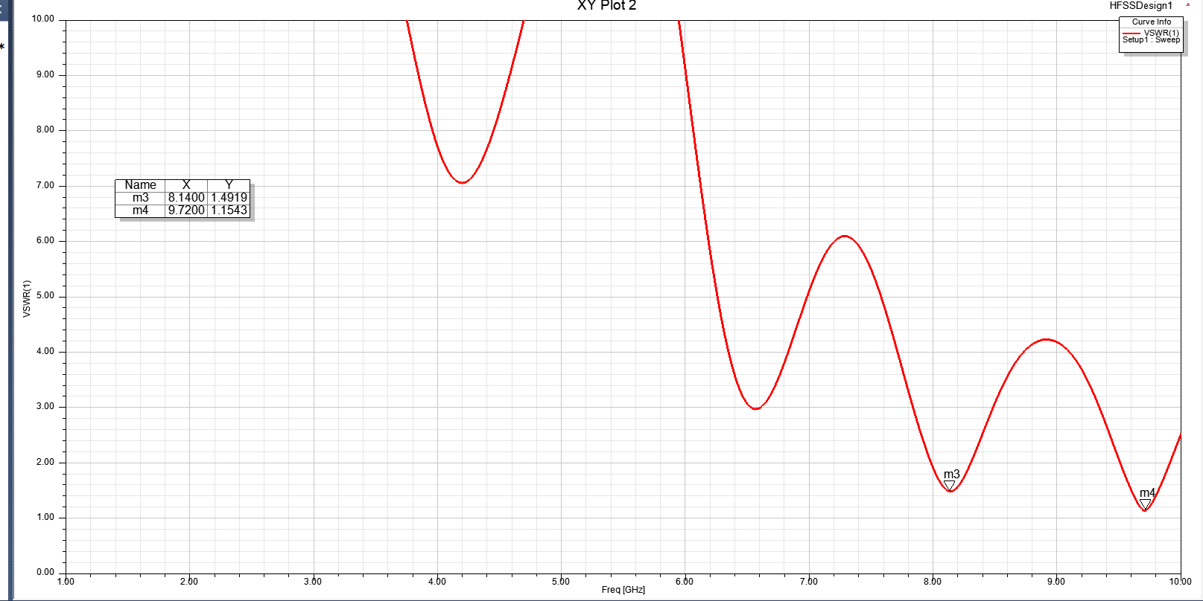

Figure.5.4(a) V s w r for Iteration-2

    - Antenna when patch is changed (Iteration-3)

a antenna with dimensions of 40 x50 mm2 is designed. This antenna operates at frequency range 8.2GHz and 9.5GHz.



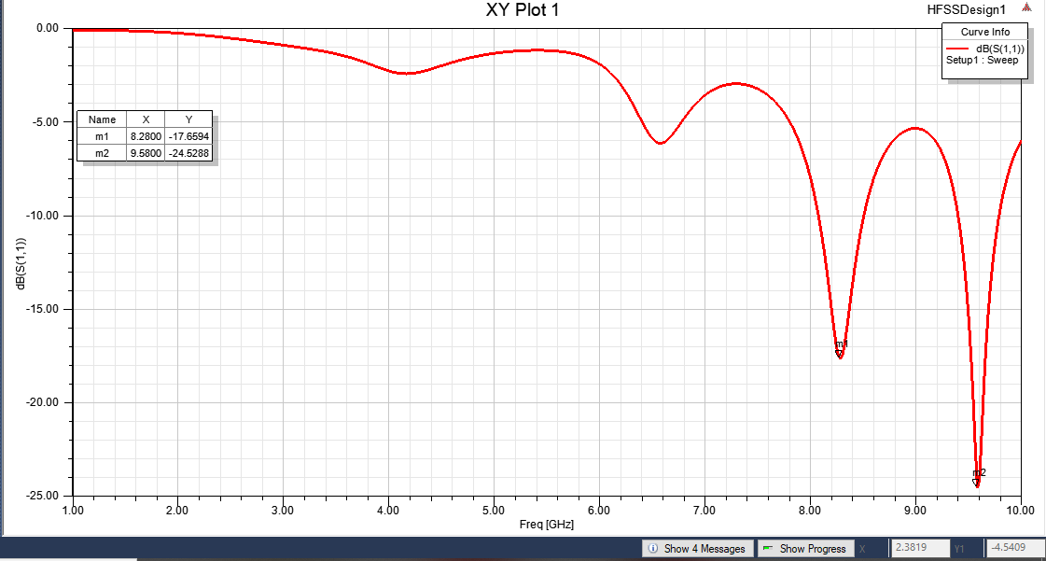
Figure.5.5 Proposed antenna (Iteration-3)
Figure.5.6 Return Loss for proposed antenna

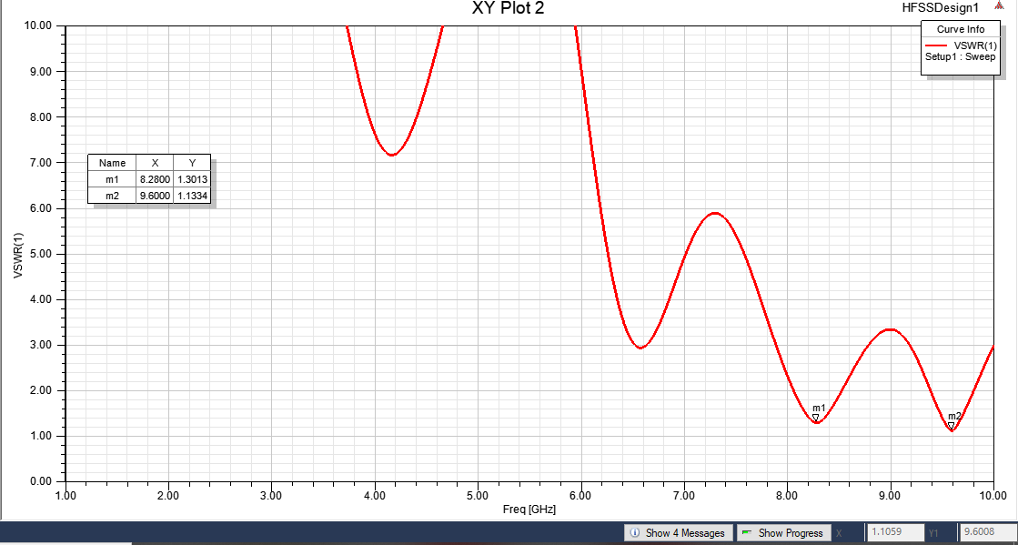

Figure.5.7 VSWR for proposed antenna

    - Antenna when substrate is changed(Iteration-4)

a antenna with dimensions of 40 x50 mm2 is designed. This antenna operates at frequency range 8.1GHz and 9.7GHz.



Figure.5.8 Proposed antenna (Iteration-4)

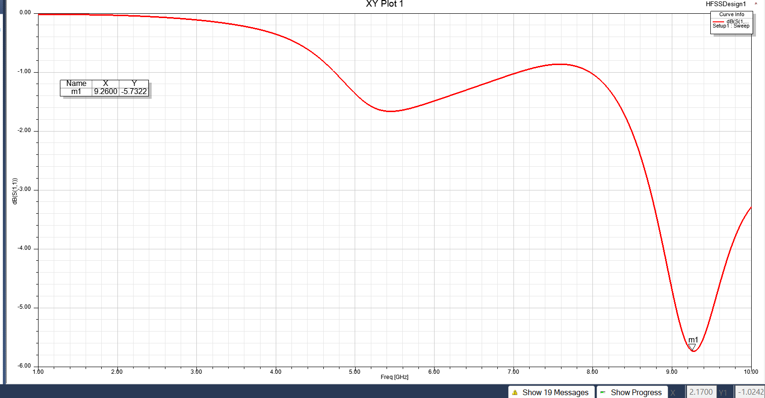

Figure.5.9 Return Loss for proposed antenna
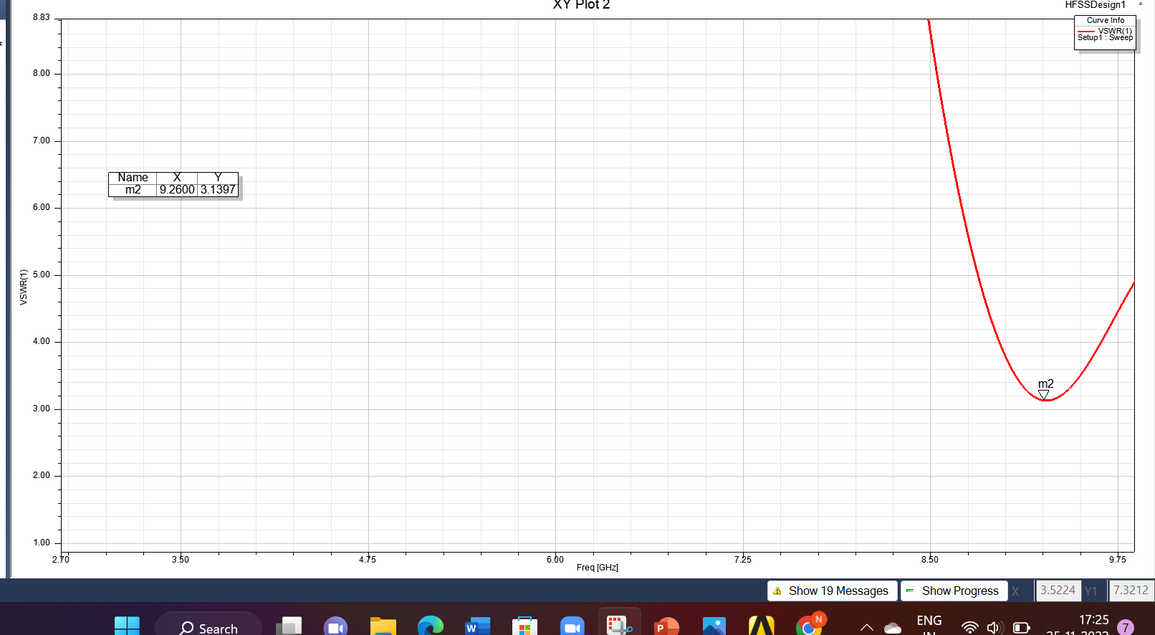

Figure.5.10 VSWR for proposed antenna

The recursive process of designing the proposed antenna is carried out by changing iteration-1 to iteration-4 to obtain high impedance bandwidthshown in Fig.5.11. Parametric analysis was carried out for different iterations of the proposed antenna and comparative variations of returnloss for design iterations (1), (2), (3),(4) are illustrated in Fig.5.12. A significantincrease in the frequency band has been observed from one iteration tothe next. The frequency spectrum covered by the iteration (3) is from 8.2GHz to 9.6GHz.
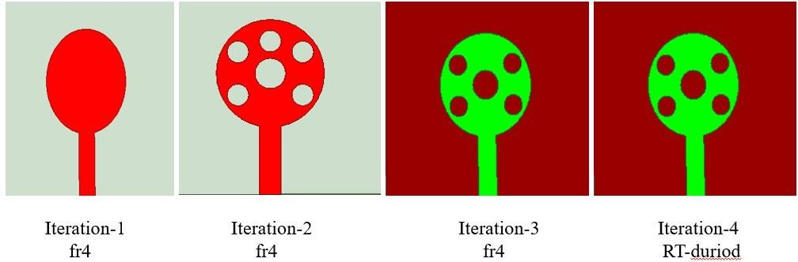

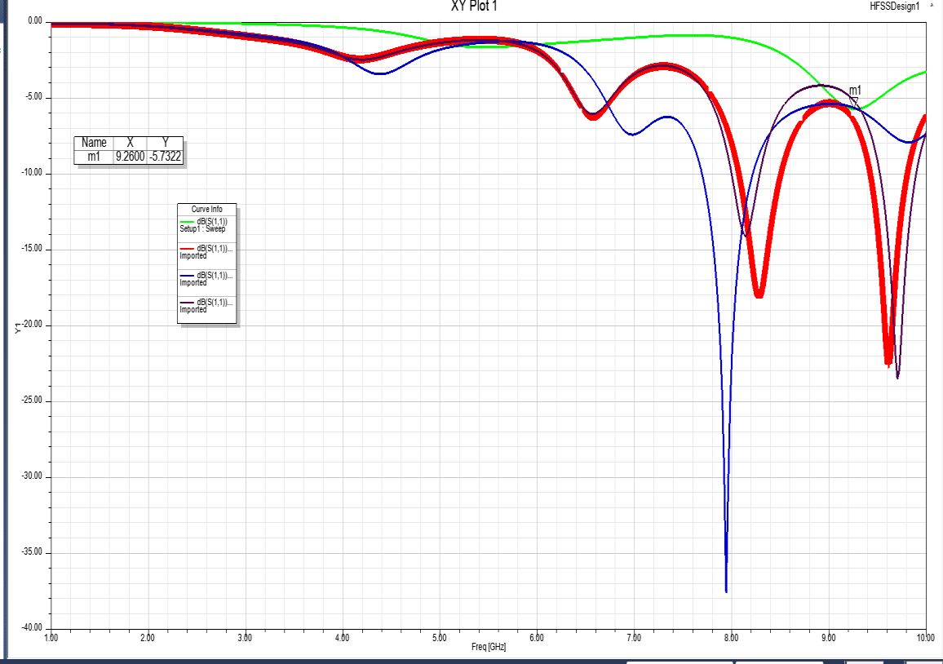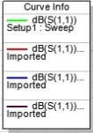Figure.5.11 Schematic configuration of Iterations-1,2,3,4
Figure.5.12 Simulated Return loss for different iterations (1, 2, 3,4)

Table.5.1: Parametric Performance analysis of various parameters variation

Parameter Variation |  | Frequency  band (GHz) | Impedance  Bandwidth (%)
Iteration | 1 | 7.7 – 8.2 | 5.58
 | 2 | 9.5-9.9 | 4.12
 | 3 | 8.2-9.5  9.4-9.8 | 4.819  4.14
Width of strip feed Wf (mm) | 1 | 16.5 | 4.14  4.819
FR 4 | εr= 4.4 | 8.2-9.5  9.4-9.8 | 4.819  4.14

VSWR

VSWR stands for Voltage Standing Wave Ratio, which is a function of the reflection coefficient, which describes the amount of reflected power from the antenna. If the reflection coefficient is given by Γ, then VSWR is defined as

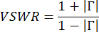

CONCLUSION
In this chapter, the characteristics of the proposed antenna areobserved along with measured results, return loss, radiation pattern, VSWR measurement, peak gain, surface current and analysis.

CHAPTER6

CONCLUSION & FUTURE SCOPE

CONCLUSION

Hence a microstrip patch antenna is designed which works under different frequencies. The substrate used here is FR4 epoxy having relative permittivity of ℇr=4.4. Thus, the improvement is accomplished for compact microstrip patch antenna structure.
The optimized dimensions of the proposed antenna were realized, fabricated and tested used for obtaining good impedance matching along with improvement in Bandwidth. Operating frequency range of 8.2GHz and 9.5GHz was observed for the designed antenna which is appropriate for wireless applications such as X-band and lower frequencies. The simulated results are observed and compared with measured results for the proposed antenna.

FUTURE SCOPE

The future scope of our project is that we can make the microstrip antenna work at number of frequencies. Additionally, we can improve the bandwidth by utilizing various defected ground structures and also, we can reduce the size of the antenna to operate at same number of frequencies as mentioned in this project.

REFERENCES
    - Abdolmehdi Dadgarpour, Amin Abbosh and Farid Jolani, “Planar Multiband Antenna for Compact Mobile Transceivers”, IEEE Antennas and Wireless Propagation Letters, 2011.

    - Bharatendra Singh Niboriya, Chetan Choudhary and Gyan Prabhakar, “S-shape Wideband Microstrip Patch Antenna with Enhanced Gain and Bandwidth for Wireless Communication”, International Journal of Computer Applications Volume 73– No.7, 2013.

    - Deependra Khandelwal, Ajay Patidar and Banwari Lal Kalwar,

“Multi-frequency Wideband M i cro s t r i p Patch Antenna for WLAN/
HIPERLAN/ SATELLITE Applications”, International Journal of Scientific Research Engineering & Technology, 2012.

    - Gazala Pravin and A. K. Rastogi, “Low cost microstrip patch antenna array for wireless communications”, JETIR 2018.

    - Houda Werfelli, Khaoula Tayari, Mondher Chaoui, Mongi Lahiani and Hamadi Ghariani, “Design of Rectangular Microstrip Patch Antenna”, 2nd International Conference on Advanced Technologies for Signal and Image Processing –2016.

    - Jing Pei, An-Guo Wang, Shun Gao, Wen Lang, “Miniaturized Triple- Band Antenna with a Defected Ground Plane for WLAN/WiMAX Applications”, IEEE Antennas and Wireless Propagation Letters, 2011.

    - Karishma D. Girase and Mandar P. Joshi, “Design of Wideband Monopole Square microstrip patch antenna”, International Conference on Communication, Information & Computing

Technology (ICCICT) ,2016.

    - Le Chang et al; Triple-Band Microstrip Patch Antenna and Its Four Antenna Module Based on Half-Mode Patch for 5G 4 × 4 MIMO Operation which operates at frequency bands of 2.47–2.75 GHz, 3.39–
3.60 GHz, and 4.69–5.10 GHz. IEEE TRANSACTIONS ON ANTENNAS AND PROPAGATION, VOL. 70, NO. 1, JANUARY 2022.

    - MHD Amen Summakieh and Mastaneh Mokayef, “Single Wideband Microstrip Patch Antenna for 5G Wireless Communication Application”, Journal of Electrical and Electronics Engineering- IJRDO, 2016.

    - M.Gunavathi, P. Ramya, D. Kavitha and P. Hamsagayathri, “Design and simulation of miniaturized UWB microstrip patch antenna for wireless communication”, International Research Journal of Engineering and Technology (IRJET), 2016.

    - Miaomiao Zuo, Jian Ren and Ying Zeng Yin “Dual-Band Antenna With Large Frequency Ratio Based on Dual-Mode Transmission Line” IEEE ANTENNAS AND WIRELESS PROPAGATION LETTERS, VOL. 20, NO. 10, OCTOBER 2021.

    - Praveen Nartam, Subhajit Chatterjee and Abhijeet Gulawani, “Design of an Ultra Wide Band Antenna using Defected Ground Structure”, International Conference on Computation of Power, Energy Information and Communication (ICCPEIC) 2016.

    - Radouane KARLI et al designed a multiband microstrip patch antenna for wireless communications . In this paper the size of the antenna is 45mm ×70mm. International Journal of Microwaves Applications,

March – April 2013.

    - S. Sri Harsha, S. Aravind Kishore and U. Rajesh, “Microstrip patch antenna using UWB for wireless communication devices”, 3rd international conference on recent innovations in science engineering and management, 2016.

    - S. Taha Imeci, Derya Arican and Hakan Hizarcioglu, “Wideband Microstrip Patch Antenna at 7 GHz”, 27th Annual Review of Progress in Applied Computational Electromagnetics, 2011.

    - S. H. S. Esfahlani, A. Tavakoli, and P. Dehkhoda ”A Compact Single-Layer Dual-Band Microstrip Antenna for Satellite Applications” IEEE ANTENNAS AND WIRELESS PROPAGATION LETTERS, VOL. 10, 2011.

    - Vivek Singh Rathor and Jai Prakash Saini, “A Design of Swastika Shaped Wideband Microstrip Patch Antenna for GSM/WLAN Application”, Journal of Electromagnetic Analysis and Applications, 2014.

    - Vyshnavi Das S, T. Shanmuganantham, “Design of Multiband Microstrip Patch Antenna For IOT Applications”, Proceedings of 2017 IEEE International Conference on Circuits and Systems (ICCS), 2017.

    - Wen-Chung Liu, Yang Dai and Chao-Ming Wu, “Design of Triple- Frequency Microstrip-Fed Monopole Antenna Using Defected Ground Structure”, IEEE Transactions on Antennas and Propagation, July 2011.

    - Yi Liu, Xi Li, Lin Yang, and Ying Liu ” A Dual-Polarized Dual-Band Antenna With Omni-Directional Radiation Patterns” IEEE TRANSACTIONS ON ANTENNAS AND PROPAGATION, VOL. 65, NO. 8, AUGUST

2017.Yuan-Ming Cai, Ke Li, Ying-Zeng Yin, and Xueshi Ren” Dual-Band Circularly polarized Antenna Combining Slot and Microstrip Modes for GPS With HIS Ground Plane” IEEE ANTENNAS AND WIRELESS PROPAGATION LETTERS, VOL. 14, 2015.

    - Yuan-Ming Cai, Ke Li, Ying-Zeng Yin, and Xueshi Ren” Dual-Band Circularly polarized Antenna Combining Slot and Microstrip Modes for GPS With HIS Ground Plane” IEEE ANTENNAS AND WIRELESS PROPAGATION LETTERS, VOL. 14, 2015.

